***Logo université partenaire*** 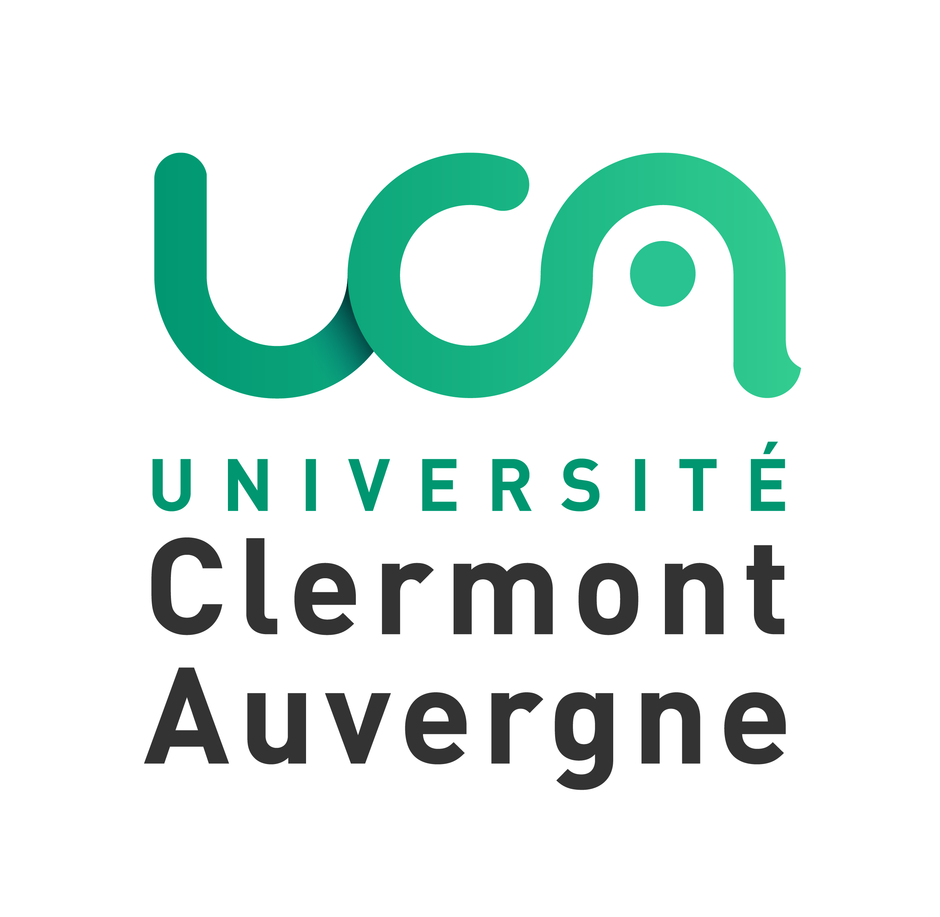

**GENERAL COOPERATION AGREEMENT**



By and between

**UNIVERSITE CLERMONT AUVERGNE - FRANCE**

Higher Education institution (tertiary level), registered under SIRET N° 130 022 775 00014, code APE8542Z to the French register of companies and establishments,

49 Boulevard François Mitterrand, 63006 Clermont-Ferrand Cedex, France

Represented by the President, **Mathias Bernard**

and

***NAME OF THE UNIVERSITY* - *COUNTRY***

***ADDRESS***

Represented by the President, ***NAME OF THE PRESIDENT***

Hereafter referred to asthe parties.

Seeking to establish partnership on educational and research programmes, the parties agree the following:

Article 1: The cooperation between the two parties will cover various activities, including:

* Exchanges of professors, researchers and administrative staff,
* The development of research programmes,
* Participation to conferences, workshops and seminars,
* Exchanges of students (degree seeking or interns),
* Exchanges of information, documentation and scientific publications,
* Co-supervision and co-direction of doctoral thesis,
* Implementation or participation to doubles degrees/ joint diplomas/ international or European projects.

Article 2: Each activity will be separately negotiated and agreed between the faculties, schools or institutes, which carry out the specific project and will be described in an addendum referring to the present agreement, to be signed by the legal representatives of both parties. All addenda are submitted to the same rules as the present agreement.

Article 3: The implementation of any of the activities listed in article 1 shall depend upon the availability of resources and financial support at the partner universities. The present agreement does not imply any financial commitment between the two parties.

The parties may, by mutual agreement, apply for grants or subsidies under intergovernmental agreements and through European and international agencies to help achieve their mutual cooperation objectives.

Article 4: Throughout the duration of this agreement and even after its expiry or termination, the parties agree to respect the confidentiality of information and documents which may have been communicated to each other during the execution of the framework agreement. Accordingly, the parties shall not disclose such information or documents to any third party. Each party shall take the necessary measures to observe this requirement.

Article 5: This Agreement and its addenda may be amended or modified by mutual agreement. Amendment(s) and modification(s) shall be additional written agreements made between the appropriate authorities of the two institutions.

Article 6: This Agreement will come into effect on the date of the last signature of both parties and remain valid for five years. On expiry, the agreement is to be renewed according to the same procedure as its original enactment. This Agreement may be terminated by either of the parties in writing by registered letter with acknowledgement of receipt, with a six months’ notice.

Article 7: Litigation related to the interpretation or performance of this agreement and which could not be amicably settled between the parties shall be referred to the competent court.

Article 8: This agreement is written in English, in two original copies

|  |  |
| --- | --- |
| UNIVERSITY OF CLERMONT AUVERGNE | XXXXX UNIVERSITY |
| President Mathias Bernard | President XXXXX |
|  |  |
|  |  |
| Date: | Date: |
|  |  |

***Logo université partenaire***



**APPENDIX REGARDING STUDENT EXCHANGES**

Given the General Cooperation Agreement signed on (date to be precised later on) between the Universities, the parties decide to agree on student exchanges for:

* Studies to be precised:

**1. Duration of Stay**

Duration of stay for students of both universities shall not exceed one academic year.

**2. Number of Exchange Students**

Each university will normally accept up to a maximum of X (X) students yearly under this Agreement, whether the duration of stay is of one or two semesters.

This number can be modified, if necessary, based on the discussion between the universities.

**3. Selection of Exchange Students**

Both parties agree that candidates to an exchange period shall be selected by the home institution. The home university will normally recommend most suitable students to the host university based on language ability and academic excellence.

Selected students must follow the host university application process and provide all required documents.

The host university reserves the right to accept or not selected students.

**4. Enrollment of Exchange Students**

(a) An acceptance letter will be sent to exchange students if necessary for visa procedure.

(b) Students from University Clermont Auvergne are registered as XX University exchange students and can attend lectures, seminars, and tutorials. Graduate students can also attend research projects.

(c) Students of XX University will register as University Clermont Auvergne exchange students and can attend lectures, seminars, and tutorials. Graduate students can also attend research projects.

(d) Exchange students will remain registered at their home institution and will not get a diploma from the host institution, unless prior mutual agreement.

**5. Study Program and Evaluation**

Each student will determine his/ her study programme at the host university in consultation with academic advisers of both host and home universities. Academic performance shall be evaluated according to the rules of the host university.

**6. Academic Record and Accreditation**

Both institutions undertake to send official transcripts of academic records to the exchange students’ home university, specifying courses studied, evaluation of performance and credits earned at the host institution. The home institution will award its students credits according to its own regulations for the recognition of studies carried out in the host university.

**7. Tuition**

Each student pays his/her fees to his/her home university. He/she is exempt from registration fees at the host institution.

**8. Accommodation**

The host university will assist students in finding accommodation.

**9. Insurance**

Students coming to UCA are required to provide proof of a valid international insurance policy until the end of the exchange period concerning:

* Personal liability,
* Sanitary repatriation,
* Medical care expenses and
* Hospital and surgical procedures expenses.

Without such policies students will be led to contract insurance in the host country.

Upon arrival at UCA, students have to get affiliated to the national social security system to cover medical care expenses, hospital and surgical procedures expenses.

**10. Financial Responsibility**

Exchange students will be responsible for their own expenses, including visa, travel expenses, accommodation costs, subsistence, medical expenses, medical insurance and health care fees.

**11. Program monitoring**

Each partner commits to appoint a correspondent person who shall monitor the actions.

|  |  |
| --- | --- |
| **For UCA Faculty/School/Department of XXXX :**  academic coordinator: Surname, FIRST NAME / Mail  administrative coordinator: Surname, FIRST NAME / Mail : | **For the XXX Faculty/School/ Department of XXXX:**  academic coordinator: Surname FIRST NAME / Mail :  administrative coordinator: Surname FIRST NAME / Mail: |

**12. Duration**

This appendix is effective from the date of signing, and remains effective until the expiration of the General Cooperation Agreement.

**13. Amendment/Termination**

This appendix is part of the General Cooperation Agreement and follows its rules.

This appendix is written in English and signed in duplicate by the universities.

|  |  |
| --- | --- |
| UNIVERSITY OF CLERMONT AUVERGNE | XXXXX UNIVERSITY |
| President Mathias Bernard | President XXXXX |
|  |  |
|  |  |
| Date: | Date: |
|  |  |



***Logo université partenaire***

**APPENDIX REGARDING RESEARCH AND STAFF EXCHANGES**

Given the Basic Cooperation Agreement between the Universities signed on (date to be precised later on), parties decide to agree on research and staff exchanges including:

* exchanges of researchers or teachers-researchers;
* exchanges of technical and scientific staff;
* exchanges of PhD students;
* thesis co-direction and/or co-supervision.

**1. Research program**

Contracting institutions encourage the implementation of research programs and the exchange of all information relating to the obtained results, as well as the organization of periodical research meetings.

Prior knowledge of each party will remain their respective property.

Results shall be the property of the parties which carrying out the work generating such results. Potential new patents resulting from such foreground shall be taken out only for the account and at the expenses of the above-mentioned parties, and on their own initiative.

The parties will draw up a co-ownership regulations relating to the new joint patents at the time of their potential deposit before any commercial and/or industrial exploitation.

The use of results will be ruled by a valuation agreement

Both parties shall submit their research publications for information. Publications can only be achieved by preserving the copyrights in the respect of each country specific law relating to intellectual property and publication.

Unless otherwise agreed, the parties commit to respect the utmost confidentiality. The transmission of the results and/or information before publication to any third party could not be done without a mutual written consent of both parties legal representative.

**2. Teaching staff exchanges**

Both institutions see advantages to developing exchanges of teachers and teacher-researchers, post-graduates, and cooperation (in the areas of………………..) provided by both Institutions.

Both institutions agree on an annual quota of staff hosted within each institution (to be defined) and on the length of their stay (to be defined).

The institutions commit to facilitate the admission and residence to the concerned persons within their capacities.

Exchange participants commit to carry out the current administrative formalities before arriving in the host country (visa, insurances, …). During their stay, they must comply with the rules of the host institutions.

Unless otherwise negotiated, invited staff are responsible for covering the costs of their travel and stay at the host university.

**3. Duration**

This Agreement is effective from the date of signing, and remains effective until the expiration of the General Cooperation Agreement.

**4. Amendment/Termination**

This agreement is part of the General Cooperation agreement and follows its rules.

This Agreement is written in English and signed in duplicate by the universities.

|  |  |
| --- | --- |
| UNIVERSITY OF CLERMONT AUVERGNE | XXXXX UNIVERSITY |
| President Mathias Bernard | President XXXXX |
|  |  |
|  |  |
| Date: | Date: |
|  |  |